Krish Patel(INT_1074)

Git – Commands Assignment

Contents
Instructions 1
TASK 1: Repository Setup 1
TASK 2: Branch Creation C Work 2
TASK 3: Branch Switching Observation 2
TASK 4: Undo a Mistake 2
TASK 5: Merge Feature Branch (6 Marks) 3
TASK 6: Checkout a Commit (Detached HEAD) (4 Marks) 3

Instructions:
- This is a local Git assignment only

Do NOT use GitHub
- Use Command Prompt / Terminal
- Commit messages must be meaningful
- Screenshots for each step in each task
- Follow steps in sequence

TASK 1: Repository Setup

Goal: Initialize Git and create first commit Steps:
- Create a folder named git-assignment-yourfullname
- Navigate into the folder
- Initialize Git repository
- Create a file named index.txt

- Check repository status
- Stage the file
- Commit with message:
Initial project setup
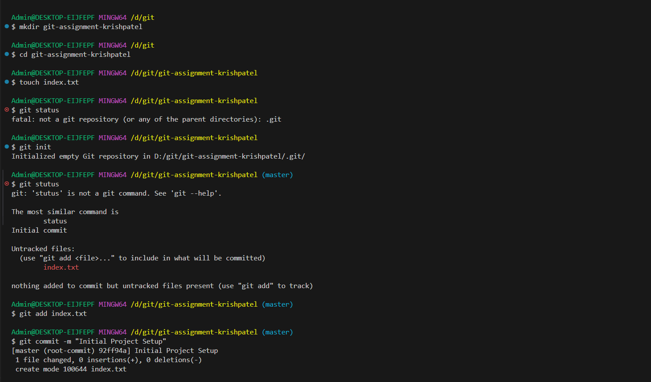

TASK 2: Branch Creation s Work

Goal: Work independently in a branch Steps:
- Create a branch named feature-header
- Switch to feature-header
- Create a file named header.txt
- Stage the file
- Commit with message:
Added header section
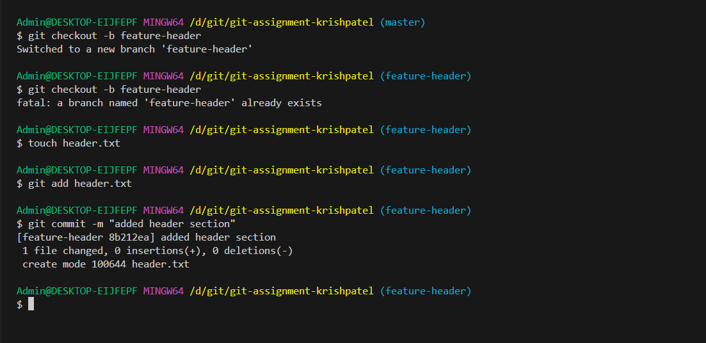

TASK 3: Branch Switching Observation

Goal: Observe branch isolation Steps:
- Switch back to master
- List files and observe
- Switch again to feature-header
- List files and observe

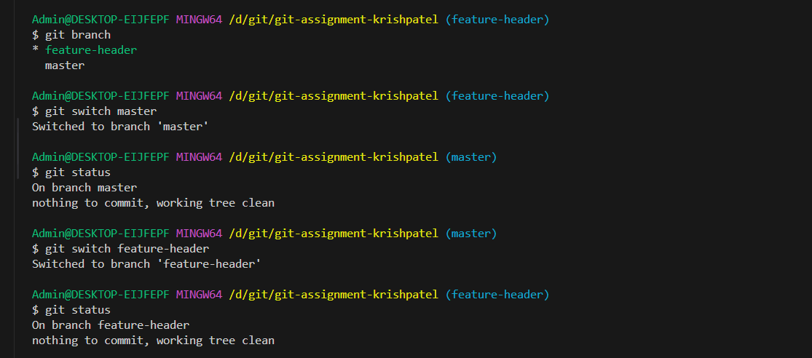

TASK 4: Undo a Mistake

Goal: Safely undo file changes Steps:
- In feature-header, modify index.txt
- Check repository status
- Undo the change using Git
- Verify status again
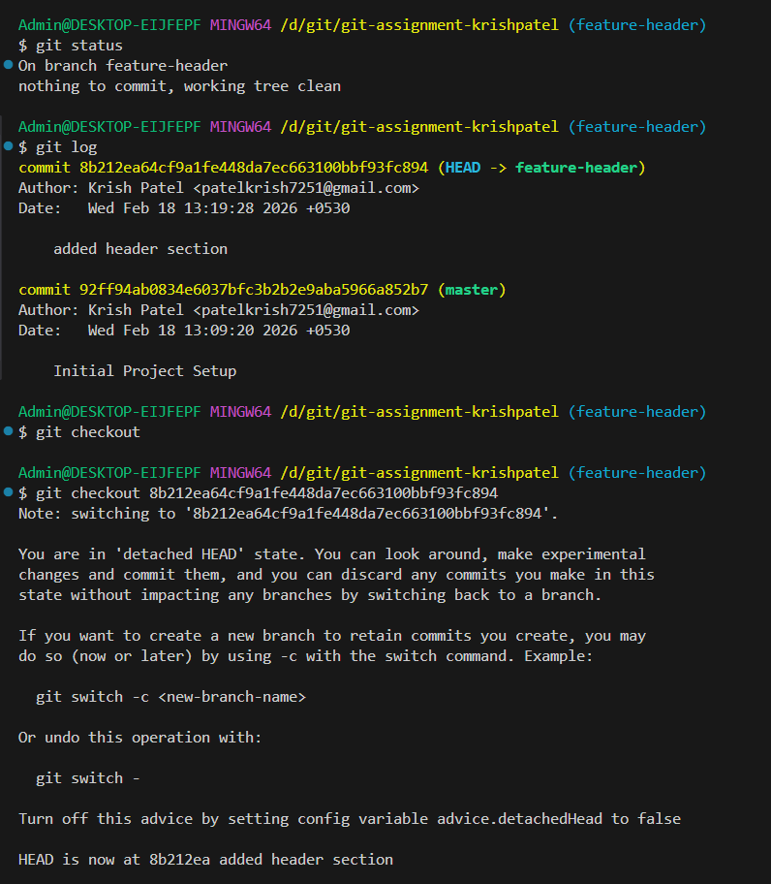

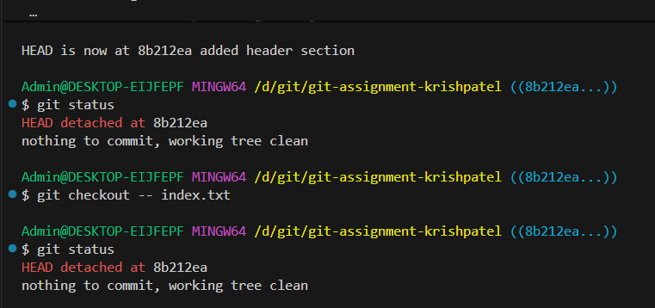

TASK 5: Merge Feature Branch

Goal: Combine work into master Steps:
- Switch to master
- Merge feature-header
- Verify merged files
- Check commit history
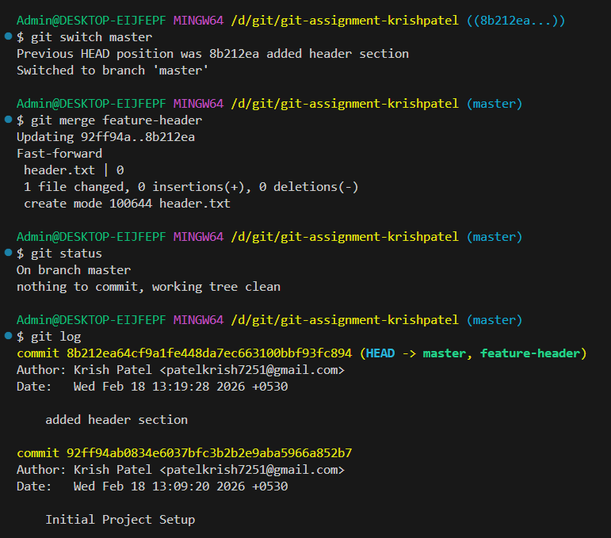

TASK 6: Checkout a Commit (Detached HEAD)

Goal: Understand commit-level navigation Steps:
- View commit history
- Checkout any older commit
- Check current branch status
- Switch back safely to master
